Predicting Life Expectancy using Machine Learning

Project Report

2020

By Nikhila Lakkaraju

NAME OF THE ORGANIZATION: SMARTINTERNZ

|  |  |  |
| --- | --- | --- |
|  |  |  |
|  |  |  |

Contents

1

INTRODUCTION

1.1 Overview

1.2 Purpose

2

LITERATURE SURVEY

2.1 Existing problem

2.2 Proposed solution

3

THEORITICAL ANALYSIS

3.1 Block diagram

3.2 Hardware / Software designing

4

EXPERIMENTAL INVESTIGATIONS

5

FLOWCHART

6

RESULT

7

ADVANTAGES & DISADVANTAGES

8

APPLICATIONS

9

CONCLUSION

10

FUTURE SCOPE

`

11

BIBILOGRAPHY

APPENDIX

A. Source code

## OVERVIEW

A typical Regression Machine Learning project leverages historical data to predict insights into the future. This problem statement is aimed at predicting Life Expectancy rate of a country given various features.

Life expectancy is a statistical measure of the average time a human being is expected to live, Life expectancy depends on various factors: Regional variations, Economic Circumstances, Sex Differences, Mental Illnesses, Physical Illnesses, Education, Year of their birth and other demographic factors. This problem statement provides a way to predict average life expectancy of people living in a country when various factors such as year, GDP, education, alcohol intake of people in the country, expenditure on healthcare system and some specific disease related deaths that happened in the country are given.

## Purpose

Life expectancy is one of the most important factors in end-of-life decision making. Good prognostication for example helps to determine the course of treatment and helps to anticipate the procurement of health care services and facilities, or more broadly: facilitates Advance Care Planning. Advance Care Planning improves the quality of the final phase of life by stimulating doctors to explore the preferences for end-of-life care with their patients, and people close to the patients. Physicians, however, tend to overestimate life expectancy, and miss the window of opportunity to initiate Advance Care Planning. This research tests the potential of using machine learning and natural language processing techniques for predicting life expectancy from electronic medical records.

# EXISTING PROBLEM

Life expectancy has doubled in all world regions. What does this mean exactly? Despite its importance and prominence in research and policy, it is surprisingly difficult to find a simple yet detailed description of what “life expectancy” actually means. In this section, we try to fill this gap. The term “life expectancy” refers to the number of years a person can expect to live. By definition, life expectancy is based on an estimate of the average age that members of a particular population group will be when they die. In practice, however, things are often more complicated: One important distinction and clarification is the difference between cohort and period life expectancy.

PROPOSED SOLUTION:

With the emergence of technologies such as electronic health and mobile health (eHealth/mHealth), Machine learning cloud computing, big data, and the Internet of Things (IoT), health related data are increasing and many applications such as smartphone apps and wearable devices that provide wellness and fitness tracking are entering the market. Some apps provide health related data such as sleep monitoring, heart rate measuring, and calorie expenditure collected and processed by the devices and servers in the cloud. These requirements can be extended to provide a personalized life expectancy (PLE) for the purpose of wellbeing and encouraging lifestyle improvement. No existing works provide this PLE information that is developed and customized for the individual.

# THEORITCAL ANALYSIS

## HARDWARE/SOFTWARE DESIGNING

* IBM CLOUD
* IBM WATSON STUDIO
* IMB CLOUD SERVICE- NODE RED APP
* ASSETS
* PROGRAMMING ENVIRONMENT
* JUPYTER NOTEBOOK
* DEFAULT PYTHON 3.6 XS

# EXPERIMENTAL INVESTIGATIONS

Initially we need to understand the working of the software’s and also get accustomed to the python notebook.

We also need to procure and download the required dataset for the project. Conditioning predictions on age for meaningful interpretation of relevant criteria across workplace and retirement domains, requires independence assumptions between work and retirement contexts. Independence of work – retirement domains is intuitively flawed, given the dependence of retirement from a previous work-life. Consequently, age is limitedly meaningful for the growing complexity and overlap of work and retirement contexts. This practical disconnect evidences in probabilistically opposing (directionally competing) age-predictions for FTP concerning the focal criteria of interest (delaying intentions/advancing preparations for retirement).

# FLOWCHART

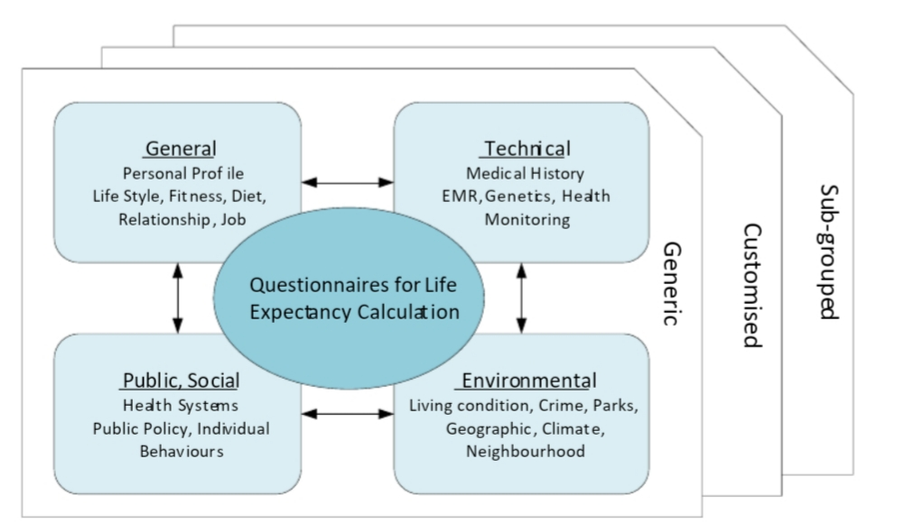

# RESULT

The life expectancy is predicted using required Machine Learning Algorithms using Linear regression model with python and as an auto AI experiment without python.

ADVANTAGES AND DISADVANTAGES

You can think of life expectancy in particular year as the age a person born in that year would expect to live if the average age of death did not change over their lifetime.

It is of course not possible to know this metric before all members of the cohort have died. Because of that statisticians commonly track members of a particular cohort and predict the average age-at-death for them using a combination of observed mortality rates for past years and projections about mortality rates for future years.

An alternative approach consists in estimating the average length of life for a hypothetical cohort assumed to be exposed, from birth through death, to the mortality rates observed at one particular period – commonly a year. This approach leads to what is known as ‘**period life expectancy**‘ and it is the much more commonly used life expectancy metric. It is the definition used by most international organizations, including the UN and the World Bank, when reporting ‘life expectancy’ figures. Period life expectancy estimates do not take into account how mortality rates are changing over time and instead only reflects the mortality pattern at one point in time. Because of this, period life expectancy figures are usually different to cohort life expectancy figures

APPLICATIONS

Real-time patient monitoring, the PLE application can be useful for users to improve their lifestyle and exercise by planning goals on a short and long-term basis. For example, the current PLE outcome of 85 years will be adjusted when the user changes their attributes such as smoking cessation, reducing alcohol consumption, commencing regular exercise, or modifying dietary plans. The development of wearable devices is evolving rapidly to capture data and for use in applications. By wearing fitness tracking or monitoring devices, those attributes can be. mHealth mobile app screens .(a) Existing health mobile app can integrate PLE feature as additional services (b) as both functions require the same physiological data to transfer to a monitoring center for PLE calculation. 5. Applications Along with existing heath applications such as fitness tracking, chronic disease monitoring and real-time patient monitoring, the PLE application can be useful for users to improve their lifestyle and exercise by planning goals on a short and long-term basis. For example, the current PLE outcome of 85 years will be adjusted when the user changes their attributes such as smoking cessation, reducing alcohol consumption, commencing regular exercise, or modifying dietary plans. The development of wearable devices is evolving rapidly to capture data and for use in applications.

CONCLUSION

Life expectancy is a statistical measure of the average time a human being is expected to live, Life expectancy depends on various factors: Regional variations, Economic Circumstances, Sex Differences, Mental Illnesses, Physical Illnesses, Education, Year of their birth and other demographic factors. This problem statement provides a way to predict average life expectancy of people living in a country when various factors such as year, GDP, education, alcohol intake of people in the country, expenditure on healthcare system and some specific disease related deaths that happened in the country are given

FUTURE SCOPE

* One possibility is that the pace of age-specific mortality improvement over the next half century will be similar to the pace of improvement over the last 50 or 100 years.
* A second possibility is that the pace of life-expectancy increase over the next half century will be similar to the rate of increase over past decades.
* Finally, the third possibility is that mortality improvements will accelerate in the future. Biology and biomedicine may be on the verge of unprecedented breakthroughs in knowledge about specific diseases and about the aging process itself – many knowledgeable scientists are of this opinion. Specifically, instead of increasing by 2.5 years per decade, life expectancy may increase by 3, then 4, and then 5 years per decade over the next three decades and perhaps by 6, 8, or even 10 years per decade in the 2030s and 2040s.